1) Write a program that checks if a given year is a leap year or not using both if-else and switch-case.

public class leapYrWithoutIfSwitch{

public static void main(String[] args){

Scanner yrObj = new Scanner(System.in);

System.out.println("Enter a year: ");

int yr = yrObj.nextInt();

String statement = ((yr % 4 == 0) && (yr % 100 != 0 || yr % 400 == 0)) ? " is Leap Year." : " is not Leap Year.";

System.out.println(yr + statement);

}

}

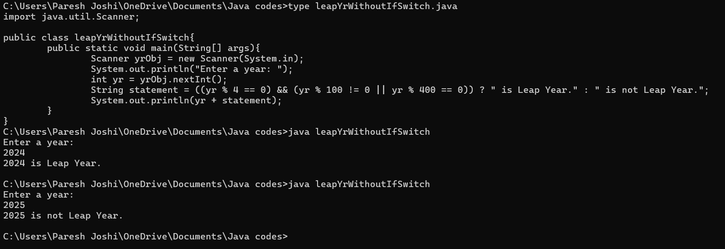

2) Implement a program that calculates the Body Mass Index (BMI) based on height and weight input using if-else to classify the BMI int categories (underweight, normal weight, overweight,etc).

import java.util.Scanner;

public class calcBMI{

public static void main(String[] args){

Scanner unit = new Scanner(System.in);

System.out.println("Enter a height in meter: ");

double ht = unit.nextDouble();

System.out.println("Enter a weight in kg: ");

double wt = unit.nextDouble();

double bmi = wt/(ht\*ht);

if(bmi<18.5){

System.out.println(bmi + ": BMI is Underweight");

}

else if(bmi>=18.5 && bmi<24.9){

System.out.println(bmi + ": BMI is Normal weight");

}

else if(bmi>25){

System.out.println(bmi + ": BMI is Overweight");

}

else{

System.out.println("You did not valid input!");

}

}

}

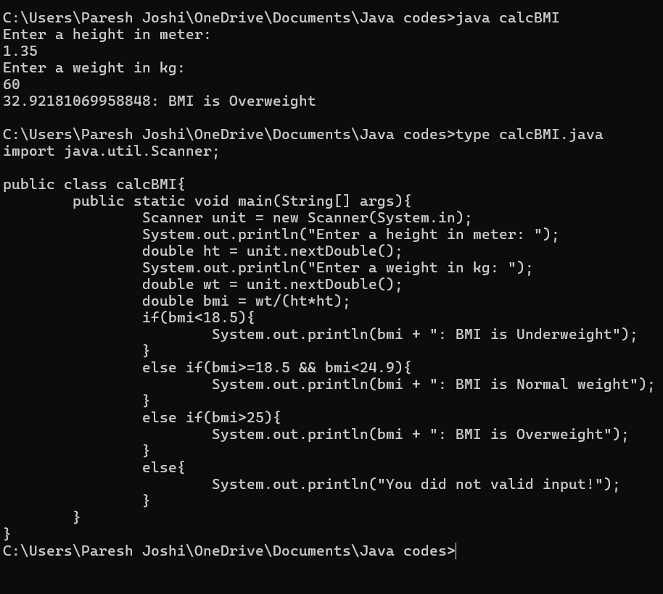

3) Write a program that checks if a person is eligible to vote based on their age.

import java.util.Scanner;

public class isVoter{

public static void main(String[] args){

Scanner unit = new Scanner(System.in);

System.out.println("Enter your age: ");

int age = unit.nextInt();

if(age<18){

System.out.println("You are not eligible for voting");

}

else{

System.out.println("You are eligible for voting");

}

}

}

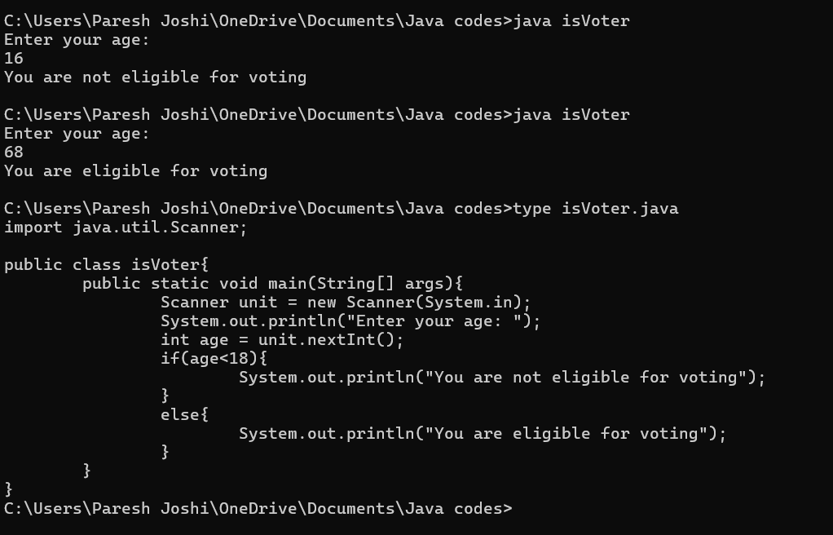

4) Write a program that takes a month (1-12) and prints the corresponding season (Winter, Spring, Summer, Autumn) using a switch case

import java.util.Scanner;

public class getSeason{

public static void main(String[] args){

Scanner unit = new Scanner(System.in);

System.out.println("Enter a month number: ");

int month = unit.nextInt();

switch(month){

case 1:

System.out.println("Winter");

break;

case 2:

System.out.println("Winter");

break;

case 3:

System.out.println("Summer");

break;

case 4:

System.out.println("Summer");

break;

case 5:

System.out.println("Summer");

break;

case 6:

System.out.println("Spring");

break;

case 7:

System.out.println("Spring");

break;

case 8:

System.out.println("Spring");

break;

case 9:

System.out.println("Spring");

break;

case 10:

System.out.println("Autumn");

break;

case 11:

System.out.println("Autumn");

break;

case 12:

System.out.println("Winter");

break;

default:

System.out.println("You did not enter a valid number!!");

break;

}

}

}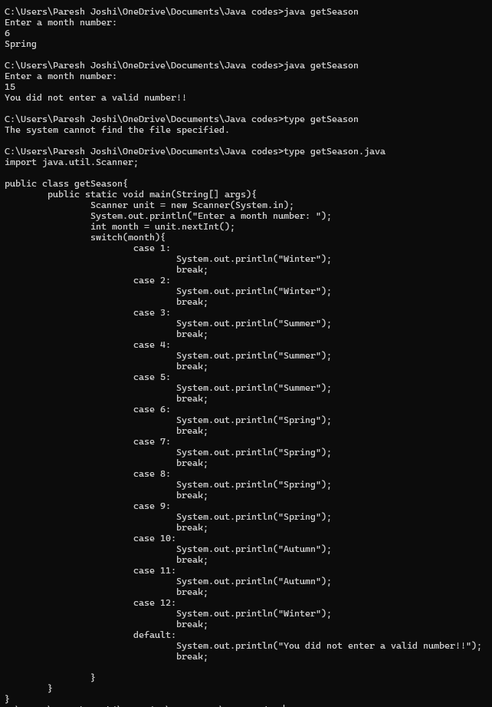

5) Write a program that allows the user to select a shape (Circle, Square, Rectangle, Triangle) and then calculates the area based on user-provided dimensions using a switch case.

import java.util.Scanner;

public class areaSwitch{

public static void main(String[] args){

Scanner unit = new Scanner(System.in);

System.out.println("Enter one of following shape");

System.out.println("Circle, Square, Rectangle, Triangle");

double area=0;

String shape = unit.nextLine();

switch(shape){

case "Circle"/\* || "circle"\*/:

System.out.println("Enter radius of circle: ");

float r = unit.nextFloat();

area = 2\*3.14\*r;

System.out.println("Area of circle is: " + (float)area);

break;

case "Square"/\* || "square"\*/:

System.out.println("Enter side of square: ");

float s = unit.nextFloat();

area = s\*s;

System.out.println("Area of square is: " + (float)area);

break;

case "Rectangle"/\* || "rectangle"\*/:

System.out.println("Enter length for rectangle: ");

float l = unit.nextFloat();

System.out.println("Enter width for rectangle: ");

float w = unit.nextFloat();

area = l\*w;

System.out.println("Area of rectangle is: " + (float)area);

break;

case "Triangle"/\* || "triangle"\*/:

System.out.println("Enter 1st side of triangle: ");

float s1 = unit.nextFloat();

System.out.println("Enter 2nd side of triangle: ");

float s2 = unit.nextFloat();

System.out.println("Enter 3rd side of triangle: ");

float s3 = unit.nextFloat();

area = s1\*s2\*s3;

System.out.println("Area of triangle is: " + (float)area);

break;

default:

System.out.println("You did not enter a valid shape!!");

break;

}

}

}

